Kite Plan Generator – Version 1.1

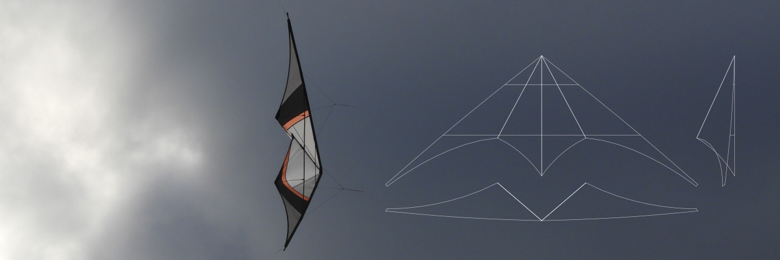

An extension for the

vector graphics program Inkscape

by Philipp and Birger Garbe

Introduction 2

Program „Inkscape“ 2

Extension „Kite Plan Generator“ 2

Installation 3

Functional description 6

Output 17

Post processing 24

3D Model 25

Sail Texture 26

Viewer 29

References 32

Note of thanks 32

# Introduction

## Program „Inkscape“

Inkscape is a professional program for creating and editing vector graphics for Windows, Mac OS X and Linux. It is free and open source software. (<https://inkscape.org/>)

## Extension „Kite Plan Generator“

The “Kite Plan Generator” is an Inkscape extension. Inkscape provides the possibility of simple functionality extensions. These consist of an input mask and a function that changes the edited document. This can be a change in one or more elements of an existing drawing, but also the addition of additional elements. The "Kite Plan Generator" inserts the views of a kite in a document on a newly inserted layer. This can be used to describe trick kites of the current design. In particular, a top view, a front view and a side view and the sail plan is generated in scale 1:10. Such a sail plan is usually the common form of a kite plan. However, a completely finished plan is not generated, but rather the starting point for the creation of such a plan. Here is presented a document view in which the well-known trick kite "Sixth Sense" by Davide Equizzi was reconstructed. A detailed description of the "Kite Plan Generator" is given in the following chapters.



# Installation

First the zip file is unpacked. All files contained in it are then copied to the extension directory. You can find out where this is, by selecting "Preferences" in the menu item "Edit" or by typing Shift + Ctrl + P.

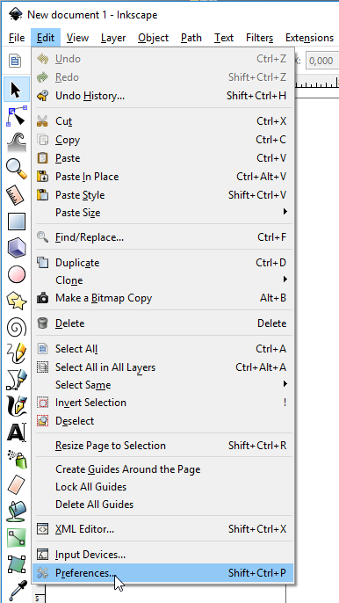

Then a window opens, in which various settings can be made. The path under which the contents of the zip file should be stored should be found in the "User extensions" field. Alternatively, you can also use the "Inkscape extensions" path. In the first case, the extension is only available to the one user in the second case to all users. It is recommended to choose the path user extensions, since this directory is still empty and you can easily find files written by the extension.

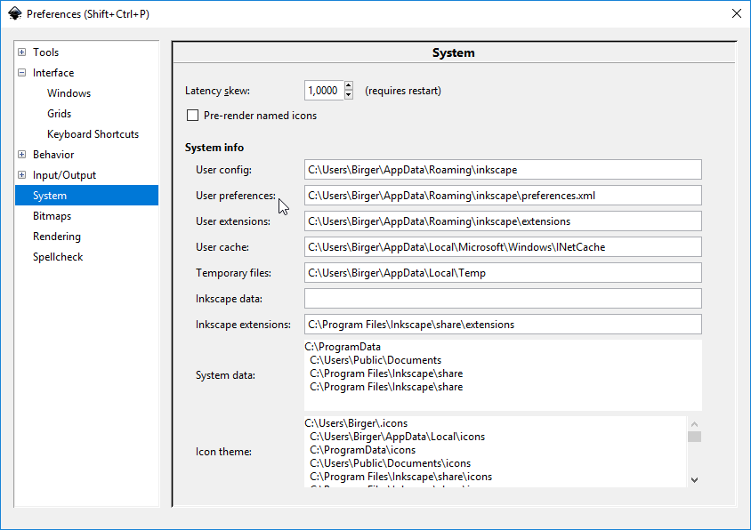

After the files are copied in the corresponding directory, the extension can be used after restarting the application "Inkscape". You can find it in the menu "Extensions" and there at "Ulzburger Kites". Alternatively, the extension can also be called with the key combination "Shift + Ctrl + K".

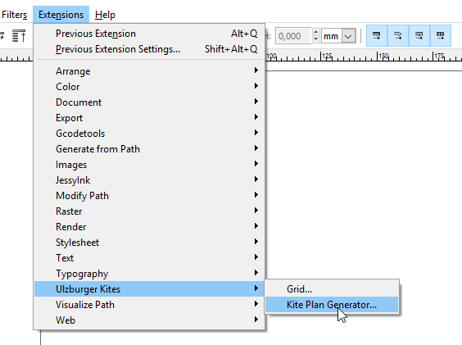

How this extension is operated and how the document is set accordingly beforehand, this will be described in detail in the next chapter.

## Functional description

**Document settings**

The extension assumes that an A4 page is available in landscape format. Starting Inkscape usually appears an A4 page in portrait format. The conversion to the landscape format is made at the "Document Properties", which can be found in the file menu. Alternatively, you can use the key combination to select Shift-Ctrl + D.

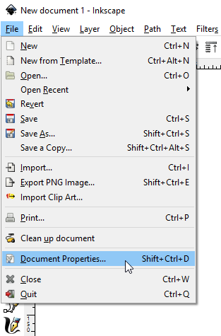

A window opens in which page size and orientation can be adjusted.

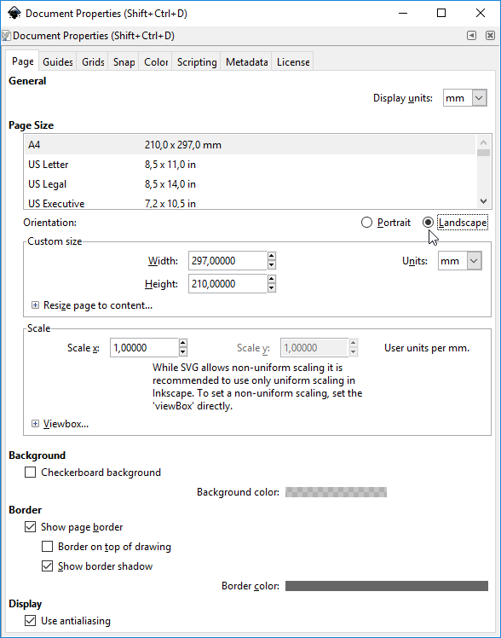

**Input values**

If the page has been set as described, the extension can now be started. First, an input mask with a number of parameters appears. If the button "Apply" is pressed, the model of a trick kite is calculated from the input values ​​and inserted into the document. If the "Live preview" option is activated, a preview of the graphical output appears during the value input.

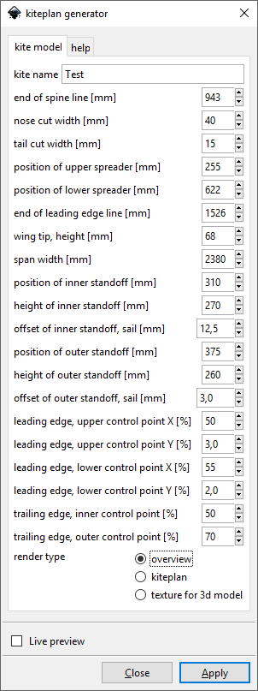

Most of these values ​​are expressed in mm, some in percent. All these values ​​taken together describe a trick kite of today's design with two standoffs on each side. If a kite is to be described with only one stand per side, this can be achieved with a small trick, which will be explained later.

Each parameter is briefly explained below. It should be noted that this is an abstract geometric model. When looking at the dimensions and intersections, one should consider that this is a model that does not accurately represent reality. This is only an approximation of a real trick kite.

**End of spine line**

This is the distance of the end of the spine line from the nose, which is the origin of the kite model geometry. Since it is not yet taken into account that later the tail and the nose are still trimmed, this information is somewhat longer than the length of the actual spine of a real kite.

**Nose cut width**

The calculated geometry of the kite model shows a kite with pointed nose. Depending on the nose design, we cut the nose to a certain width. This width is indicated here and a corresponding cut mark is drawn in the sail plan.

**Tail cut width**

Same as for the nose also applies at the tail. Depending on the tail, the tail is cut to a certain width. This width is indicated here and a corresponding cut mark is drawn in the sail plan.



**Position of upper spreader**

This describes the point at which the upper cross point crosses the spine. It is the distance to the unclipped nose tip.

**Position of lower spreader**

This describes the point at which the lower cross point crosses the keel line. It is the distance to the unclipped nose tip.

**End of leading edge**

This determines the distance of the wing tip, i.e. the end of the leading edge, to the zero point or the nose. This value is not to be confused with the length of the leading edge.



**End of leading edge, height**

This value is understandable when you look at a dragon lying on the ground. Then this is the height of the wing tip above the ground, or above the plane on which the spine is located. Again, it should be noted that the geometric model differs from the values ​​in reality. In the real kite, the spine and spreaders do not run in a single plane as assumed here. So here real values and the model differ somewhat.

**Span width**

This value is used to specify the span, in this case the distance between the two ends of the leading edge. This is then used to influence the opening angle of the guide edges. Further values ​​such as the lengths of the spreaders are also influenced thereby.



**Position of inner standoff**

This value describes the distance of the inner standoff on the lower spreader to the spine line.

**Height of inner standoff**

The height of the sail point at which the inner stand meets the sail is described here.

**Offset of inner standoff, sail**

This parameter describes the offset of the sail point at which the inner standoff meets the sail toward the stern. If this value is greater than zero, the standoffs are slightly oblique in the room.



**Position of outer standoff**

This applies to the "inner standoff" previously described.

**Height of outer standoff**

This applies to the "inner standoff" previously described.

**Offset of outer standoff, sail**

This applies to the "inner standoff" previously described.



Note: With the kite model described here, basically only kites with two standoffs can be described. If, however, a model with only one standoff is to be displayed, then a position is specified for the second standoff that is only 1 mm next to the first standoff, and the same standoff lengths are always selected. These standoffs, standing close together, represent the one standoff of the real kite. The offset values ​​are still variable parameters, which are still used in the modelling of the trailing edge.

The leading edge is described as a Bezier curve of the second degree or a cubic Bezier curve (https://de.wikipedia.org/wiki/B%C3%A9zierkurve). For this purpose, two control points are required in addition to the start and end points. The two control points are shown in the graphical output of the detail view of the leading edge.

**Leading edge, upper control point X**

**Leading edge, upper control point Y**

This is the position of the first control point from the nose, based on the total length of the leading edge base line.



**Leading edge, lower control point X**

**Leading edge, lower control point Y**

This is the position of the second control point from the nose, based on the total length of the leading edge base line.



The trailing edge is described by two Bezier curves of the first degree and an intermediate straight line. For this purpose, two control points are required. The position of the two control points is indicated in the graphical view of the sail plan.

Note: If the straight line connecting the two control points should rotate, the offsets of the standoffs must be changed accordingly.

**Trailing edge, inner control point**

This percentage value determines the position of the control point of the inner part of the trailing edge. 0% is the point where the inner stand touches the sail, 100% is the point where the connecting line of the standoff points intersects the spine line.

**Trailing edge, outer control point**

This percentage value determines the position of the control point of the outer part of the trailing edge. 0% is the point at which the outer standoff touches the sail. At 100% the point of the connecting line of the standoff points intersects with the leading edge baseline.



## Output

In addition to the graphical output, which includes a top view, a front view and a side view, the plan in scale 1:10 and a detail of the leading edge, some values ​​derived from the calculated kite model are written as output. These will now be described.

**Total height**

The total height, calculated from elevation difference from the nose and the leading edge end.

**Nose angle**

This is the angle which the two leading edge lines form.

**Inner angle**

This is the angle which the two inner sail surfaces form to one another.



**Upper spreader**

This is the calculated length of the upper spreader. The real length of the upper spreader is shorter since no connectors are considered in the model.

**Lower spreader**

This is the calculated length of the lower spreaders per side. The real length of the lower spreaders is also shorter since no connectors are considered in the model.



**Leading edge, upper part**

This is the length of the upper part of the leading edge, i.e. distance from the nose to the point where the upper spreader line meets the leading edge curve.

**Leading edge, middle part**

This is the length of the middle part of the leading edge, i.e. distance from the point at which the upper spreader line meets the leading edge curve, to the point at which the lower spreader line meets the leading edge curve.

**Leading edge, lower part**

This is the length of the lower part of the leading edge, i.e. distance from the point at which the lower spreader line meets the leading edge curve, to the end of the leading edge.



**Spine, upper part**

This is the length of the upper part of the spine, i.e. distance from the nose to the point where the upper spreader crosses the keel.

**Spine, middle part**

This is the length of the central part of the spine. That is the distance from the point where the upper spreader crosses the spine, to the point where the lower spreader crosses the spine.

**Spine, lower part**

Length of the lower part of the spine, i.e. distance from the point at which the lower spreader crosses the spine, to the end of the spine.



**Nose cut**

This is the length of the piece around which the spine is shortened at the nose.

**Tail cut**

This is the length of the piece around which the spine at the tail is shortened.

**Cut spine**

This is the length of the shortened spine.



**Cut leading edge**

This is the length of the leading edge arc, shortened by the cut on the nose.

**Leading edge height**

This is the height of the leading edge arc over the leading edge base line.



**Sail area (projection)**

This is the surface of the sail in the top view. Note: Twice the area marked in the graphic.

**Sail area (plan)**

This is the surface of sail in plan. Note: Twice the area marked in the graphic.



# Post processing

If a kite model has been designed with the previously described Inkscape parameters, the next step is to create a concrete blueprint. First, a 1: 1 plan is generated from the sail outline by selecting "kite plan" as "Render type". If you like, you can use the "overview" option to add the overview image to the plan.

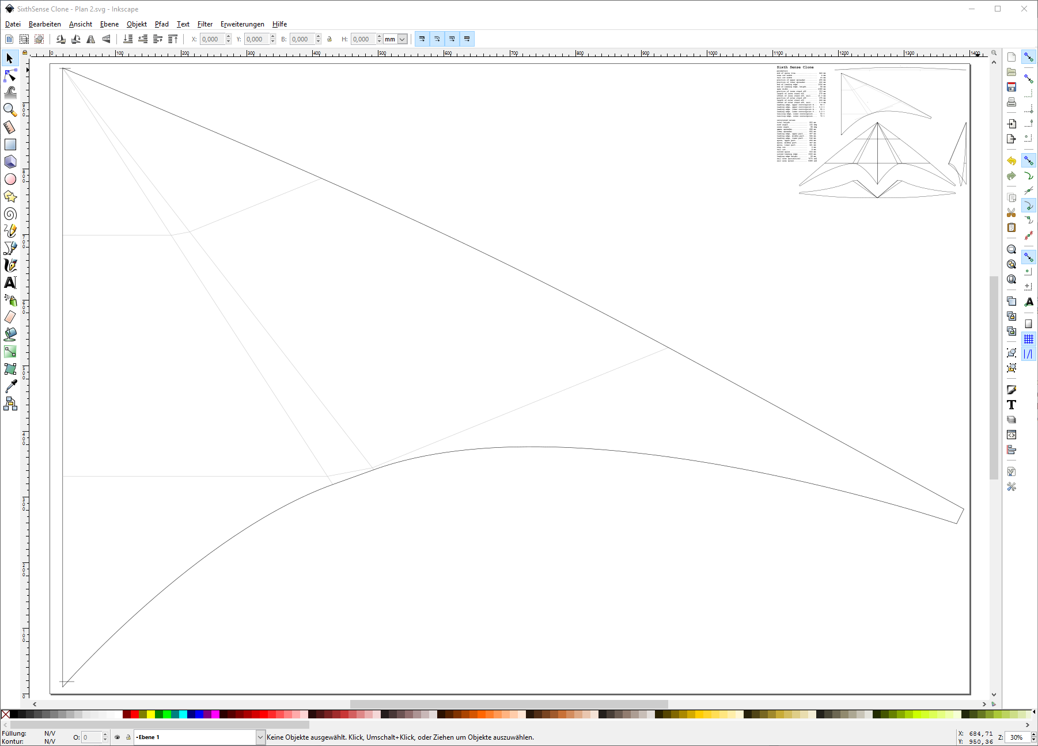

The steps that are now required for the creation of a complete plan, with design and close-ups, etc., are not explained here. If this is done in Inkscape, it is essential to familiarize yourself with this program.

The designer is also free to refine the previously existing raw form of a sail plan. For example, leading edge or trailing edge can be reworked as desired. Because Inkscape is capable of exporting to various graphics formats, these steps can also be made with other applications, e.g. a CAD program.

# 3D Model

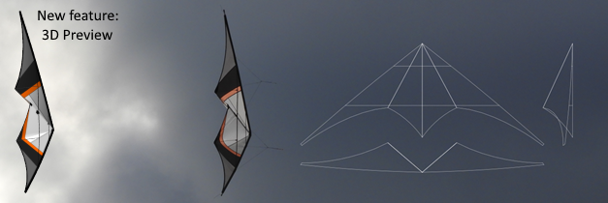

When the Inkscape extension calculates the kite model for the graphical output in the document, the tool creates two files that contain the corresponding 3D model. One of these files has the extension OBJ, which essentially contains the coordinates of the 3D object. The other file has the extension MTL, it contains descriptions to the materials of the object, in our case for the sail and the carbon rods. The MTL file contains references to image files with the extension PNG. These image files then contain a graphic of the sail design. The decryption how to create these image files follows in the next chapter. First of all, an example of such a 3D model:

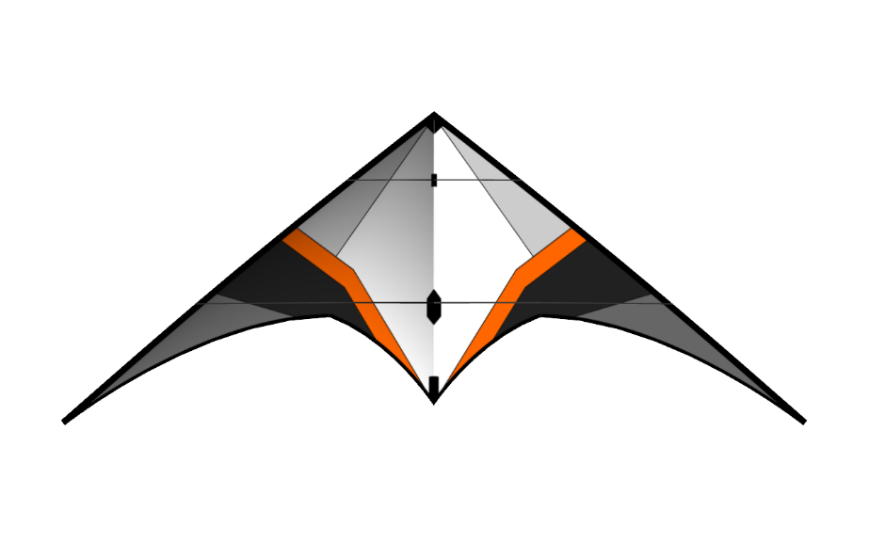

The model "Proof of Concept" (POC) was the first kite built using this generator.

In addition to previewing a model in the design process, you can also use these 3D models for other purposes very well. Here is an example of the sequence of a trick: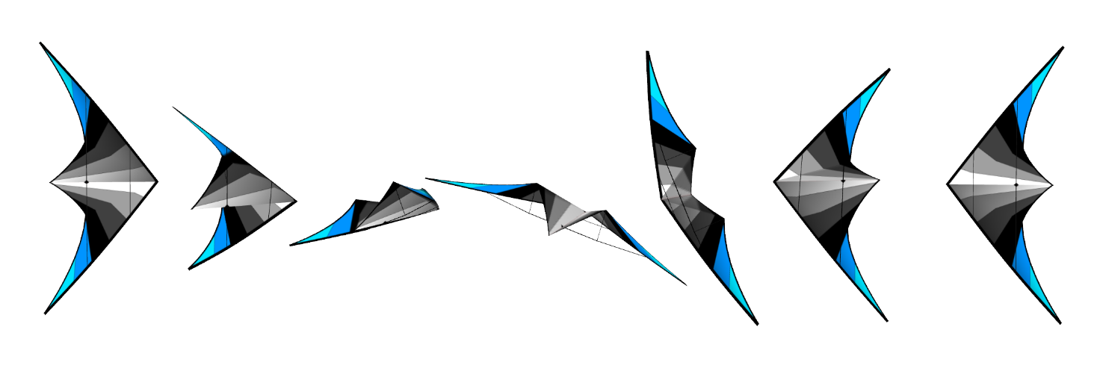

## Sail Texture

The 3D model needs one or two image files that contain the texture of a sail half. Two files are required if the design of the sail halves is asymmetrical. Here we learn how to use the generator to create a template for the texture and how it is in a 3D model.

First, we create a layer with the texture template in the Inkscape document:

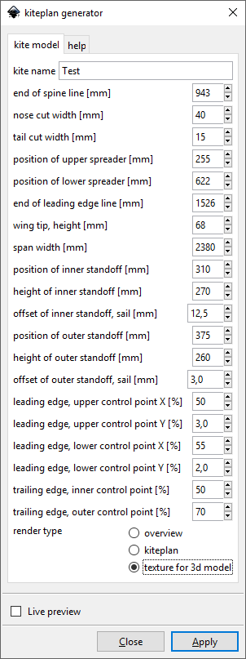

As "render type", "texture for 3D model" is selected and the "Apply" button is pressed.

The result is a texture template with a few markers:

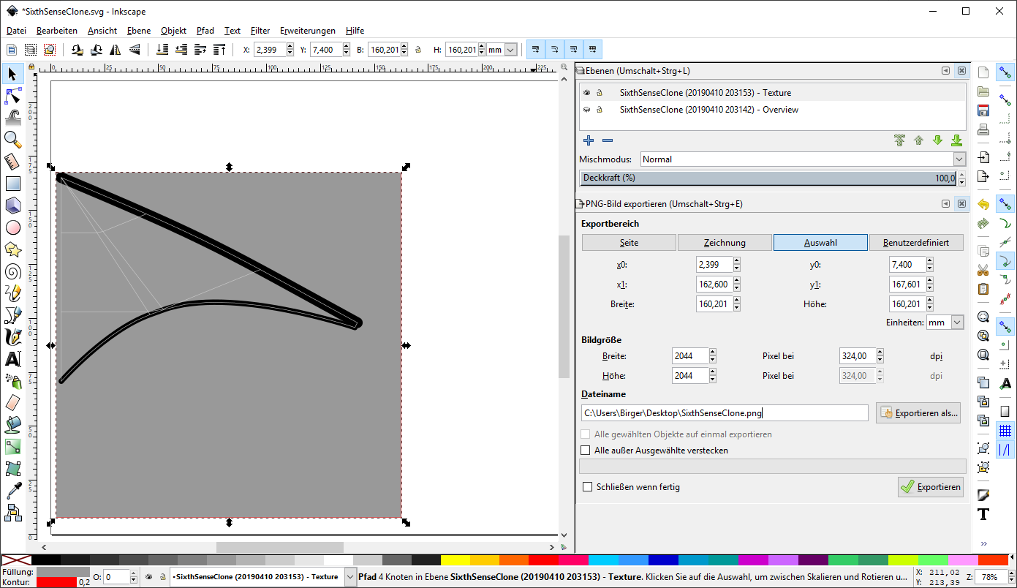

Now the gray square is marked with the red frame and exported as a PNG graphics file with 2048x2048 pixels. Here you give the file the name of the kite model, which was also used for the already created by the kite generator OBJ and MTL files. There are then three files: SixthSenseClone.obj, SixthSenseClone.mtl, and SixthSenseClone.png. The resulting 3D model now looks like this in a 3D viewer:

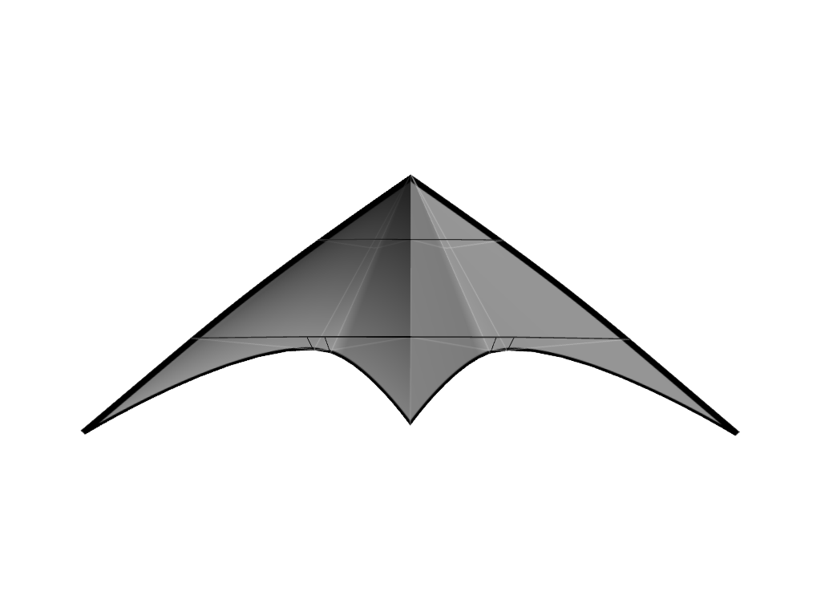

The next step in Inkscape is to draw the sail design using the generated template. This is not described in detail here. However, it takes a little practice with Inkscape.

For the example of the Sixth Sense Clone, the original design has been redrawn and exported again as a PNG file.

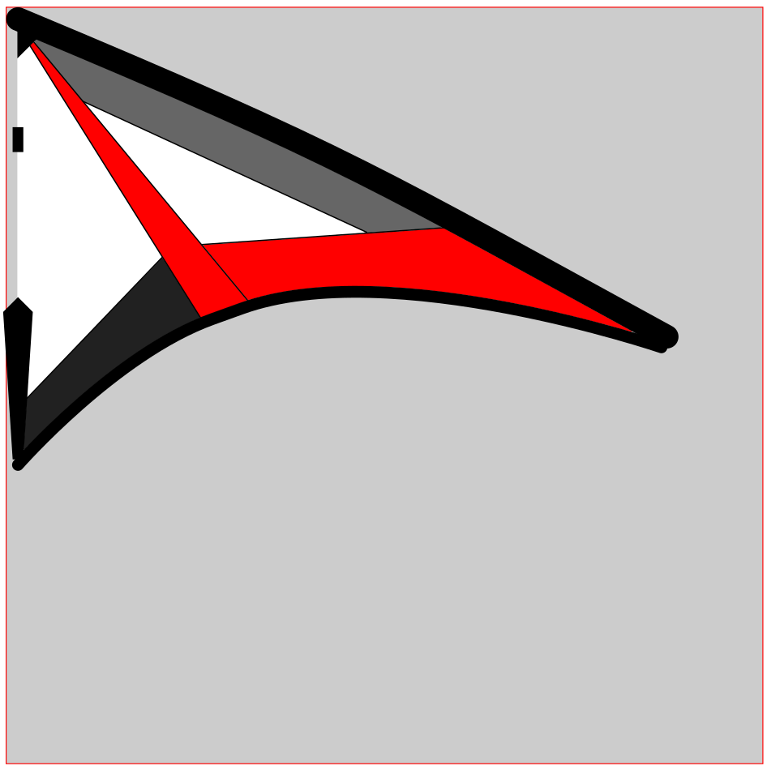

Finally, you get a 3D model that looks very close to the original.

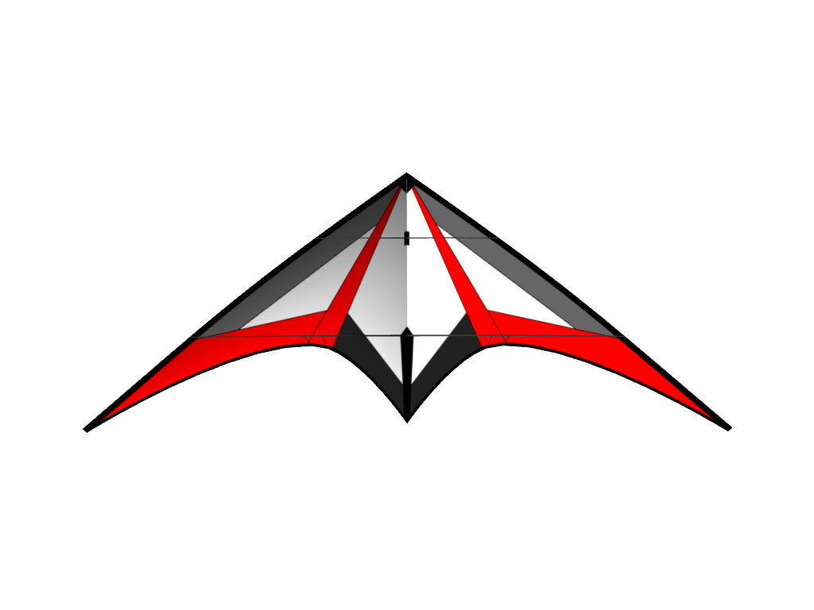

## Viewer

**Web Viewer**

On the website <https://3dviewer.net> an interactive web viewer for 3D models is provided, with which we can display our models. For this, we open the three (or four) files of the model.

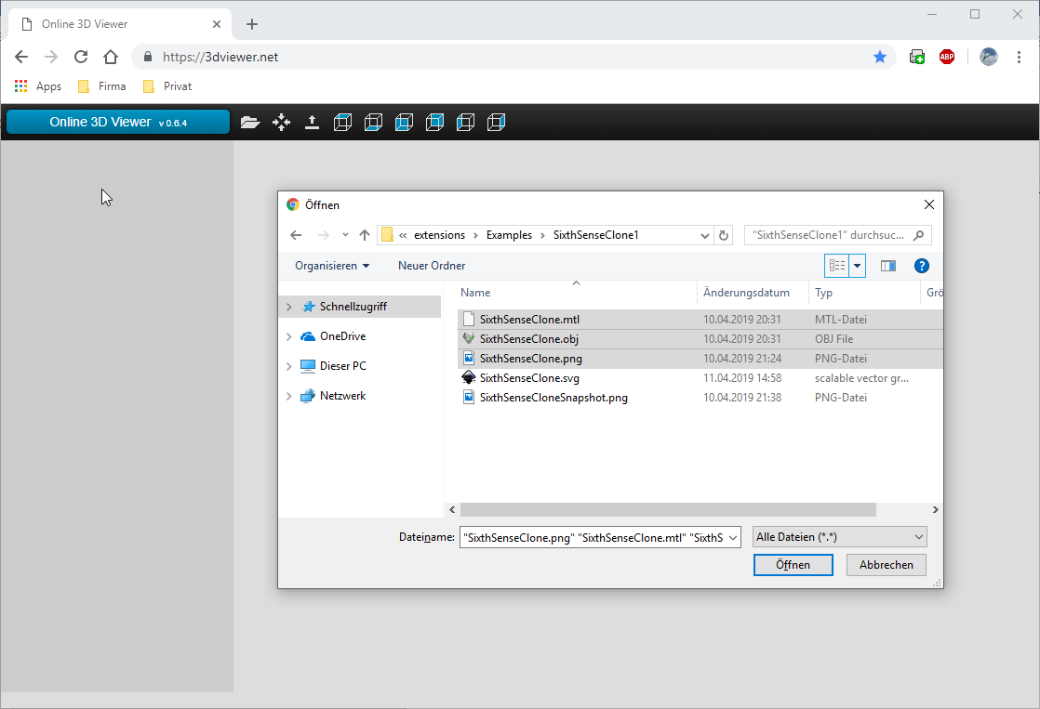

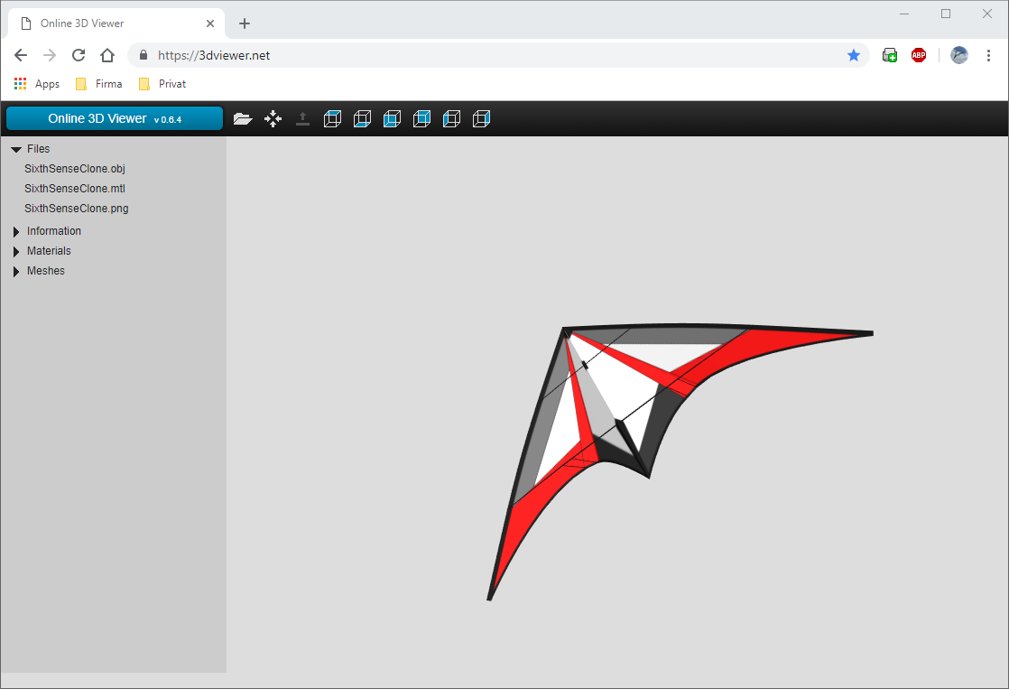

**Viewer Applikation**

As an example, we use the application GLC player (http://www.glc-player.net) to display the 3D model of a kite. The GLC-Player application is relatively easy to use and offers us some useful features: Screenshots with any background images or with a transparent background. A simple lighting and of course the interactive turning of the model in the room. If the file extension "obj" is linked to this program on the PC, then a double-click on such a file loads it including the linked textures, in the assumption they are stored in the same directory.

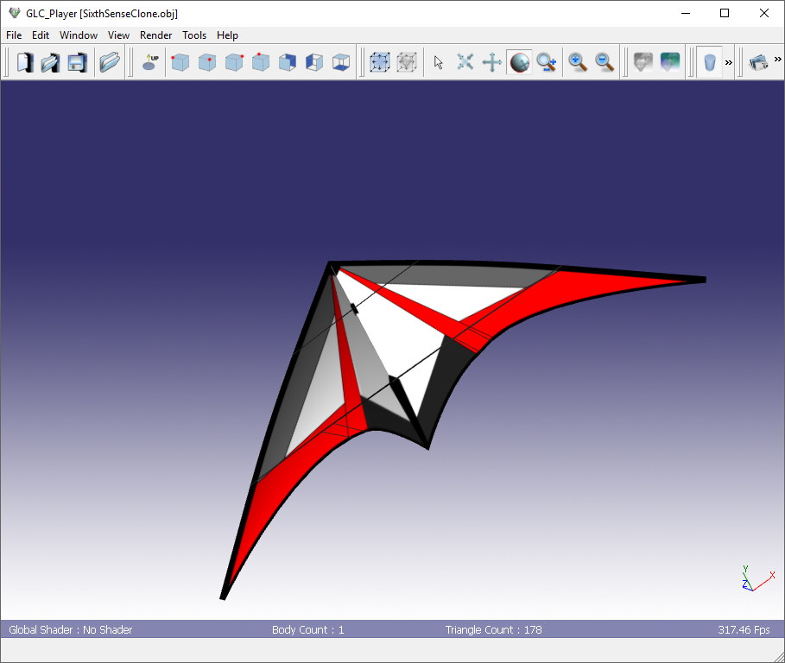

Export of the view as an image, here with a transparent background:

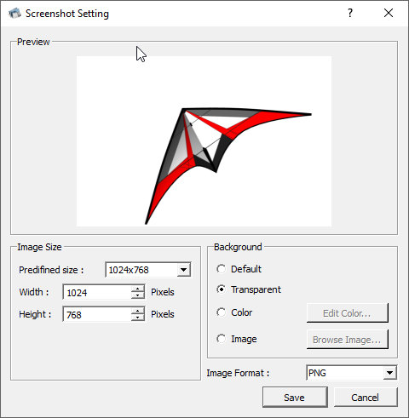

**Inkcape**

The Inkscape extension "3D Polyhedron", which can be found in the "Extensions - Render - 3D Polyhedron" menu, offers a little less interaction.

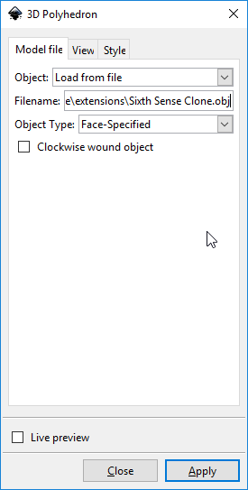

Here is the output of the Inkscape extension:

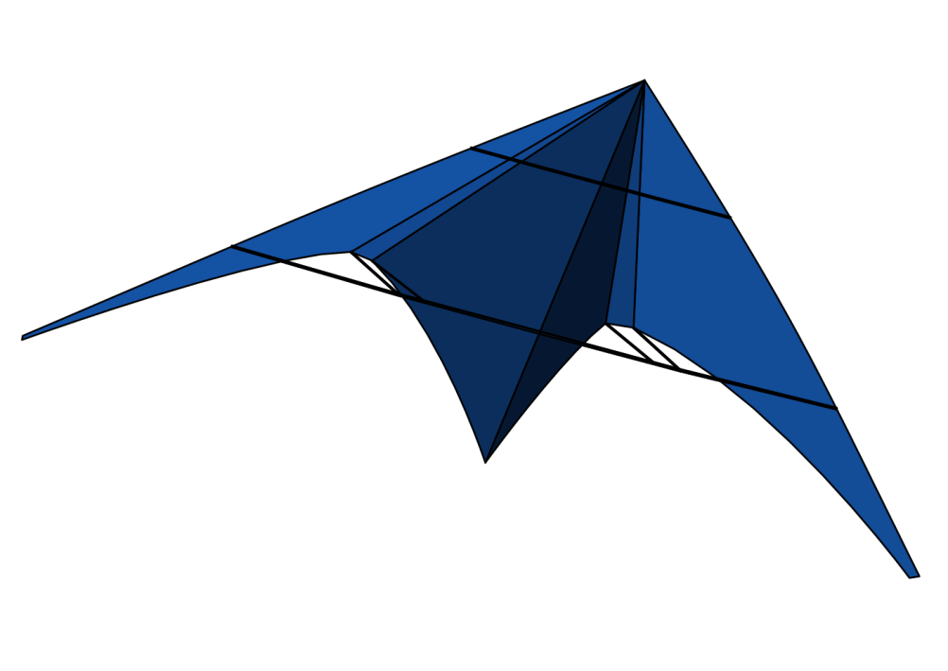

# References

* The original plan of the "Sitxh Sense" by Davide Equizzi:  
  <http://www.kareloh.com/kite-plans/2175-2/>
* Mario Di Biase's article on the computer-assisted design of trick-kills has inspired this software solution:  
  <http://blog.giochivolanti.it/progetti/pav/>
* This work describes an equivalent solution as a Blender add-on:  
  Bachelor thesis "Development of an add-on for the computer-aided construction of delta-shaped stunt kites", Philipp Garbe, 2017

# Note of thanks

We have to thank two users regarding the creation of version 1.1. On the one hand Grischa König, who provided valuable feedback during the final development of the 3D feature as a test user. In addition, Ian Perks who has given hints on the English translation of the user interface and document output.

Birger Garbe, Ulzburg the 12.04.2019